PBL Phase 2 Report
End to End Pre Loan Default Assessment System
Project Id: AIML-2

Name: Rishith Arora
Class Roll no. : 25
University Roll no. : 2519150
Section : X

Name: Tarun Pratap Singh
Class Roll no. : 31
University Roll no. : 2519550
Section : X

Name: Priyanshu Bisht
Class Roll no. : 23
University Roll no. : 2519458
Section : X

Index

S.no. | Title | Page
1. | Problem Description | 3
2. | Architecture | 3-4
3. | Models used | 5
4. | Evaluation metrics used | 5-6
5. | Preliminary Results and Visualizations | 7-8
6. | References | 9

1. Problem Description
The financial sector faces significant risks from 'credit risk,' where borrowers fail to repay loans, leading to substantial economic losses. This project aims to develop a predictive model that identifies potential 'loan defaulters' based on historical customer banking data. By leveraging classification algorithms, banks can automate the risk assessment process, ensuring more objective and data-driven lending decisions. In real life, this minimizes non-performing assets (NPAs) and helps maintain the stability of the banking ecosystem.

2. Architecture
The system follows a structured machine learning pipeline designed for high-stakes financial data:
- Data Acquisition: Importing the Loan_default dataset.
- Data Preprocessing: Handling missing values, noise, and outliers using IQR and statistical imputation.
- Feature Engineering: Transforming categorical variables and scaling numerical features via Standard Scaler.
- Dimensionality Reduction: Using PCA to select the most significant components to reduce noise and training time.
- Classification: Training models like SVM and KNN.
- Deployment/Analysis: Providing probability scores for default likelihood.

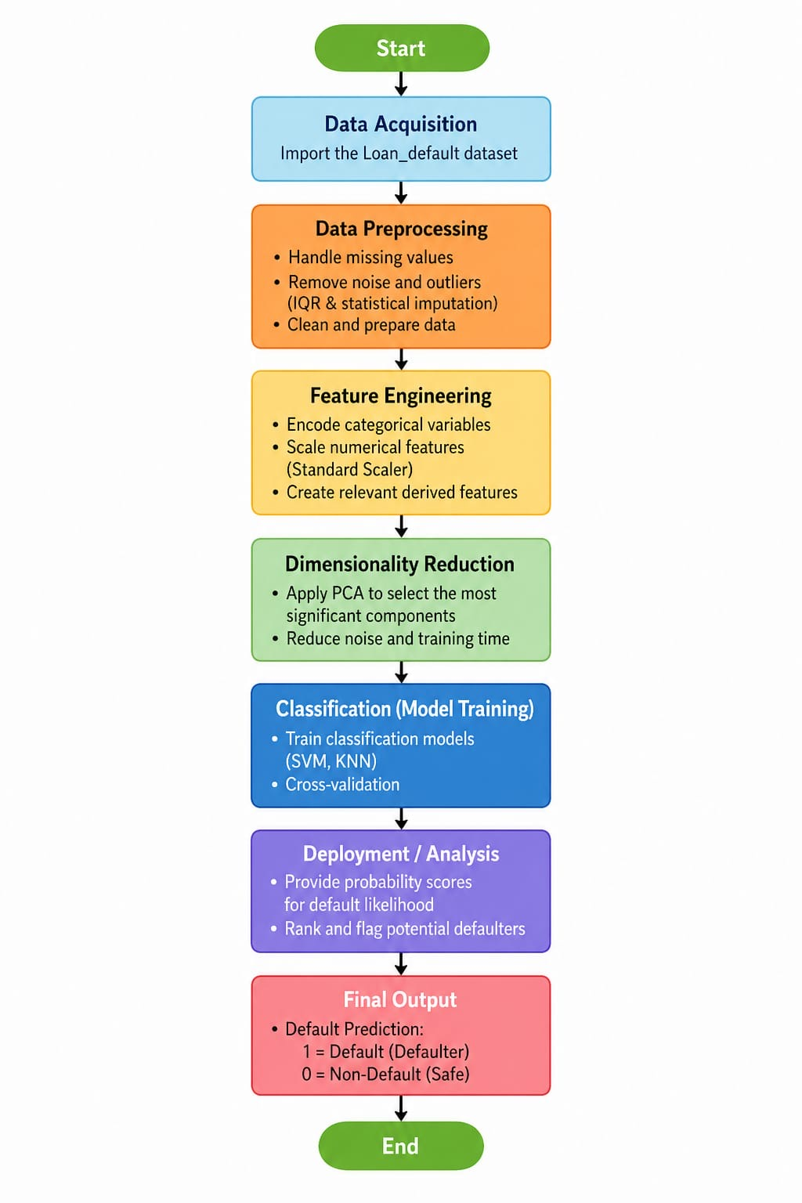
Fig 1: Flow diagram of the proposed system.

3. Models Used

Support Vector Machines (SVM)
SVM is used to find the optimal hyperplane that maximizes the margin between classes (Default vs. Non-Default). We utilize various kernels such as Linear, Poly, and RBF to handle non-linear relationships in the banking data.

K-Nearest Neighbors (KNN)
KNN classifies a borrower based on the characteristics of the 'K' most similar historical customers. It is effective for identifying patterns in borrower behavior without assuming a specific data distribution.
Principal Component Analysis (PCA)
An unsupervised model used to compress the feature space. It identifies the principal components that explain the maximum variance in the banking dataset, helping the classifiers run faster and potentially avoid overfitting.
Logistic Regression (Planned/Baseline)
While the core analysis focuses on SVM and KNN, the reports and synopsis mention Logistic Regression as a baseline model. This is a statistical model used for binary classification. It estimates the probability of an event (default) occurring based on input features using a logistic function.
Random Forest Classifier
Random Forest is an "Ensemble Learning" method that operates by constructing a multitude of Decision Trees during training. It makes a final prediction by taking the majority vote (for classification) from all the individual trees.

4. Evaluation Metrics Used
- Accuracy: Percentage of total correct predictions.

- Recall: Critical in banking; it measures the ability to identify all actual defaulters to minimize losses.

- F1-Score: Provides a balance between Precision and Recall, ensuring the model isn't biased.

- Confusion Matrix: Visualizes the performance of the classification algorithm. A confusion matrix shows:
- True Positive (TP)
- True Negative (TN)
- False Positive (FP)
- False Negative (FN)
Importance:
Helps analyze model performance

Identifies misclassification

- Heatmap (Confusion Matrix Visualization)
A heatmap visually represents the confusion matrix using colors.
Advantages:
Easy interpretation
Detects errors quickly

5. Preliminary Results and Visualizations
Initial Exploratory Data Analysis (EDA) shows that interest rates and credit scores are the most significant indicators of default. Heatmaps generated during the analysis helped identify multi-collinearity between features.

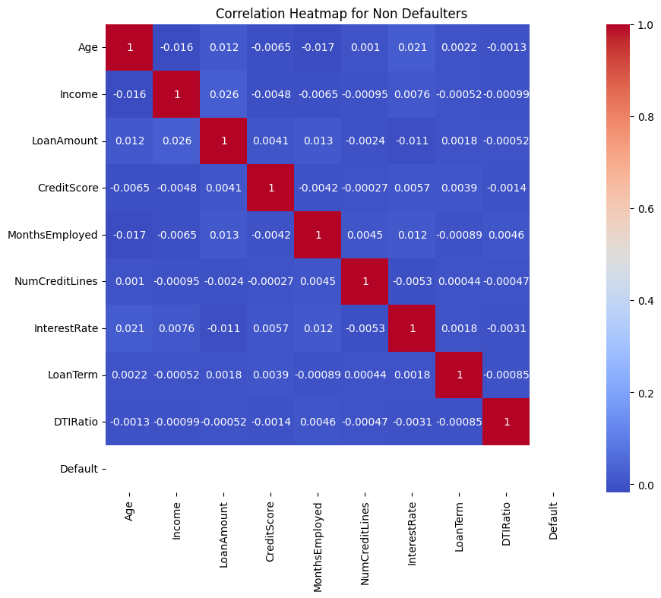
Fig 2: Figure showing Heatmap of the Feature correlation
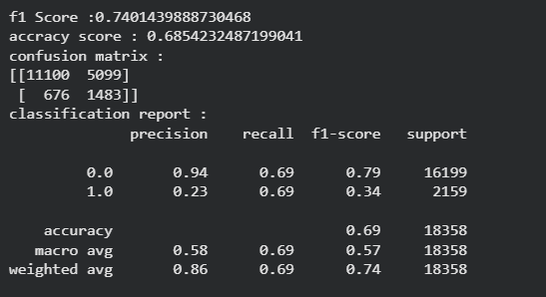
Fig 3: Figure showing linear SVC report
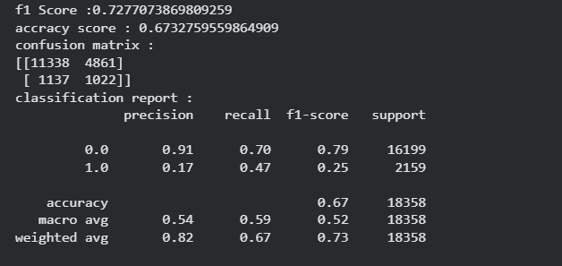
Fig 4: Figure showing knn report

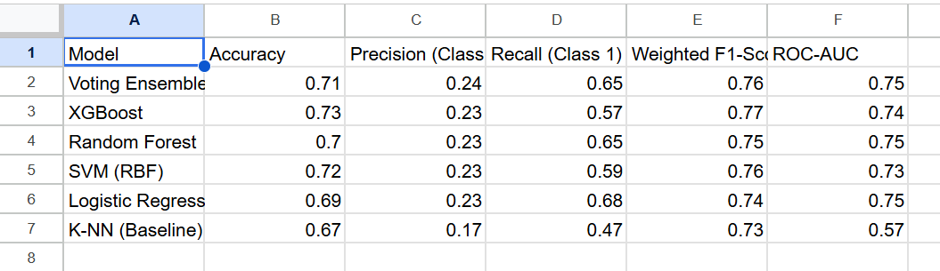
Fig 5: Figure showing information about all models used

6. References

Books:
- 1. Hands-On Machine Learning with Scikit-Learn, Keras, and TensorFlow – Aurélien Géron
- 2. Pattern Recognition and Machine Learning – Christopher Bishop

Online Resources:
- 1. Scikit-Learn Documentation: https://scikit-learn.org/
- 2. Pandas Official Guide: https://pandas.pydata.org/

